Why Send For Peter?
Prepared by Nathan L Morrison for Sunday September 24th, 2023
Text: Acts 10:5

Why Send For Peter…?

- If “Morally Right” Saves? (Acts 10:1-2)
  - _________________________________
  - _________________________________
  - _________________________________
- If Saying a Prayer Saves? (Acts 10:2)
  - _________________________________
  - _________________________________
  - _________________________________
- If Angels Preach to Men? (Acts 10:3-8)
  - _________________________________
  - _________________________________
  - _________________________________
- If Men Are Saved by Visions? (Acts 10:3)
  - _________________________________
  - _________________________________
  - _________________________________
- If Holy Spirit Baptism Saves? (Acts 10:44-46)
  - _________________________________
  - _________________________________
  - _________________________________

Why Send For Peter?

- Cornelius Needed to Hear the Word of God (Acts 10:30-33)
  - _________________________________
  - _________________________________
  - _________________________________
- Men Are Saved by Gospel Preaching (Acts 11:13-14; I Cor. 1:21)
  - _________________________________
  - _________________________________
  - _________________________________
- Obedience is Necessary (Acts 10:47-48)
  - _________________________________
  - _________________________________
  - _________________________________
- Repentance is Commanded (Acts 11:18)
  - _________________________________
  - _________________________________
  - _________________________________
- Baptism Saves! (Acts 10:47-48)
  - _________________________________
  - _________________________________
  - _________________________________

Acts 10:47-48
47. "Surely no one can refuse the water for these to be baptized who have received the Holy Spirit just as we did, can he?"
48. And he ordered them to be baptized in the name of Jesus Christ. Then they asked him to stay on for a few days.

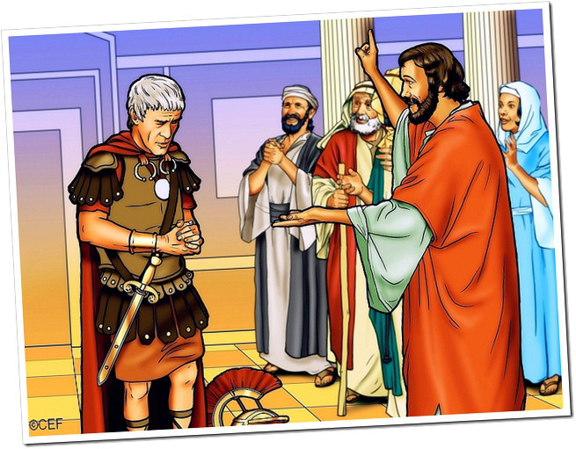

Morrison Publishing, 2023

Why Send For Peter?
Prepared by Nathan L Morrison for Sunday September 24th, 2023
Text: Acts 10:5

Acts 10:5
“Now dispatch some men to Joppa and send for a man named Simon, who is also called Peter.”

