Why Be Baptized?
- Jesus said to be baptized as an act of faith in order to be saved – Mt. 28:19; Mk. 16:16
- Baptism is a command (NAS: “ordered”/ESV, KJV, NKJ: “commanded”) – Acts 10:48
- To be saved – Mark 16:16; I Peter 3:21
- For the forgiveness of sins – Acts 2:38; Col. 2:12-13
- To wash away sins – Acts 22:16
- To be cleansed/washed by the word – Eph. 5:26; I Cor. 6:11
- To be regenerated – Titus 3:5
- To walk a new life – Rom. 6:3-5
- To appeal to God for a good conscience – I Pet. 3:21
- To enter the one body, the church (Eph. 1:22-23; 4:4; Col. 1:18) – I Cor. 12:13 (Eph. 5:23)
- To enter the kingdom of God – John 3:5
- To be born again by water and the Spirit – John 3:5 (Acts 2:38)
- To get into Christ – Rom. 6:3; Gal. 3:27 (Mt. 28:19; Acts 2:38: Baptized into His name)
- To share in the death, burial, and resurrection of Jesus – Rom. 6:3-9; Col. 2:9-14 (Baptism symbolizes Christ’s death, burial, and His resurrection; “newness of life”)
- To put on Christ – Gal. 3:27 (Rom. 13:14: “Put on the Lord…”)
- To seek things above – Col. 3:1-3 (to be raised up with Jesus, we need to be baptized into Jesus – Rom. 6:4-5; Col. 2:12; Acts 8:29)
- To not reject the counsel of God – Luke 7:30 (By rejecting John’s baptism they rejected God’s will; if people reject the baptism commanded by Jesus they reject the will of God!)
- Baptism is an act of faith in Jesus – Acts 19:4-5
- To justify (KJV/NKJ) God – Luke 7:29 (if baptism of John showed the justice of God, how much more so to be baptized in the baptism of Jesus?! – 19:4-5)
- Why be baptized? Jesus commands it as an act of faith (obedience) to be forgiven of sins and be saved!

Who Should Be Baptized?
- Those who are taught, who hear the word of God – Mt. 28:18-20; Acts 18:8: Crispus and the Corinthians; Acts 19:4-5: Ephesian disciples (Rom. 10:14, 17)
- Those who believe – Mark 16:16; Acts 8:12-13, 36-37; 18:8; 19:4-5 (Rom. 10:8-13)
- Those who repent of their sins – Acts 2:38
- Those who confess Jesus is the Son of God – Acts 8:36-37 (Rom. 10:8-10)
- Those who receive the word of God – Acts 2:41; 8:12-14
- Those who wish to enter the one body (church) through the one baptism – I Cor. 12:13 (Eph. 4:4-6)
- Those who want their sins forgiven and to be saved! – Mark 16:16; Acts 2:38; 22:16
- Who should be baptized? All those who want to obey the gospel (the word of God)!

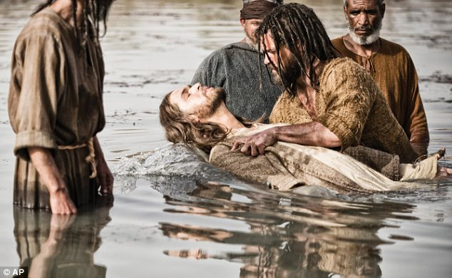

What Is Baptism (How)?
- Baptism is a transliteration of a Greek word, baptizo (G907).
- Strong’s (G907) says, “to make whelmed (that is, fully wet); to immerse.”
- Thayer says:
  - 1) to dip repeatedly, to immerse, to submerge (of vessels sunk)
  - 2) to cleanse by dipping or submerging, to wash, to make clean with water, to wash one’s self, bathe
  - 3) to overwhelm
- One must go to water – Acts 8:36 (“much water” – John 3:23). People went out to John, who was baptizing at the Jordan – Mark 1:4-5
- Go down into the water – Acts 8:38 (not needed if sprinkling and pouring acceptable)
- A burial (sharing/uniting in the death and burial of Jesus) – Rom. 6:3-5; Col. 2:12 (rules out sprinkling and pouring, for neither of those symbolize a burial!)
- Be washed – Acts 22:16; I Cor. 6:11; Eph. 5:26-27; Heb. 10:22
- A new birth – John 3:5; Rom. 6:4; I Pet. 2:1-3
- Raise up out of the water (sharing in Jesus’ resurrection) – Acts 8:39; Rom. 6:4-5, 8; Col. 2:12 (Rules out sprinkling and pouring as they don’t fit the example or the symbolism).
- What is baptism? How should one be baptized? Fully immersed in water for the forgiveness of their sins, in the name of the Father, Son, & the Holy Spirit (Mt. 28:19)!
(Adapted from a chart by Kyle Coe)
Morrison Publishing 2019
www.courthousechurchofchrist.com; 804-277-1983

Baptism Part 2: WWW?Baptism
Prepared by Nathan L Morrison for Sunday July 28th, 2019
Text: Ephesians 4:4-6

Why? Who? What? Of Baptism

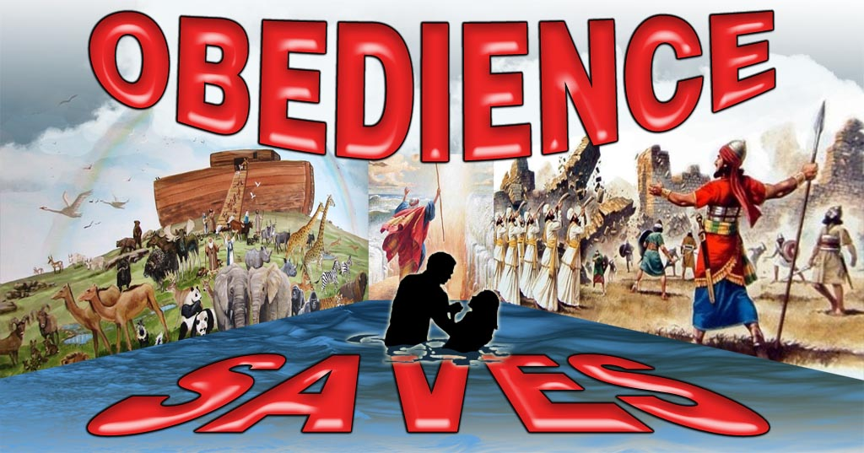

Ephesians 4:4-6
4. There is one body and one Spirit, just as also you were called in one hope of your calling;
5. one Lord, one faith, one baptism,
6. one God and Father of all who is over all and through all and in all.

What do the Scriptures say about the Why, Who, and What (How) concerning baptism?

