Old Testament Archaeology

- Black Obelisk of Shalmaneser III
Collection: __________________________
Who Discovered it: ___________________
Date of Discovery: ___________________
Location of Discovery: ________________
Date of Event: _______________________
Significance: ________________________
- Tel Dan Stele
Collection: __________________________
Who Discovered it: ___________________
Date of Discovery: ___________________
Location of Discovery: ________________
Date of Event: _______________________
Significance: ________________________
- The Hittites
Collection: __________________________
Who Discovered it: ___________________
Date of Discovery: ___________________
Location of Discovery: ________________
Date of Event: _______________________
Significance: ________________________ ________________________

New Testament Archaeology

- Politarch Inscription
Collection: __________________________
Who Discovered it: ___________________
Date of Discovery: ___________________
Location of Discovery: ________________
Date of Event: _______________________
Significance: ________________________
- Pilate Stone
Collection: __________________________
Who Discovered it: ___________________
Date of Discovery: ___________________
Location of Discovery: ________________
Date of Event: _______________________
Significance: ________________________ C. Sergius Paulus Inscription
Collection: __________________________
Who Discovered it: ___________________
Date of Discovery: ___________________
Location of Discovery: ________________
Date of Event: _______________________
Significance: ________________________

Further Study

Books
- Archaeology and the Bible by Mike Willis
- Dead Sea Scrolls by San Diego Natural History Museum
- The Exodus Case by Dr. Lennert Moller
- The Stones Cry Out: How Archaeology Reveals the Truth of the Bible by Randall Price

Online Resources
- Top Ten Discoveries in Biblical Archaeology Relating to the Old Testament by Bryan Windle
  - https://biblearchaeologyreport.com/2019/01/19/top-ten-discoveries-in-biblical-archaeology-relating-to-the-new-testament/
- Top Ten Discoveries in Biblical Archaeology Relating to the New Testament by Bryan Windle
  - https://biblearchaeologyreport.com/2019/01/12/top-ten-discoveries-in-biblical-archaeology-relating-to-the-old-testament/
- www.bibleplaces.com
- www.biblearchaeology.org

Morrison Publishing, 2021

The Stones Cry Out
Prepared by Nathan L Morrison for Sunday July 11th, 2021
Text: Luke 19:40

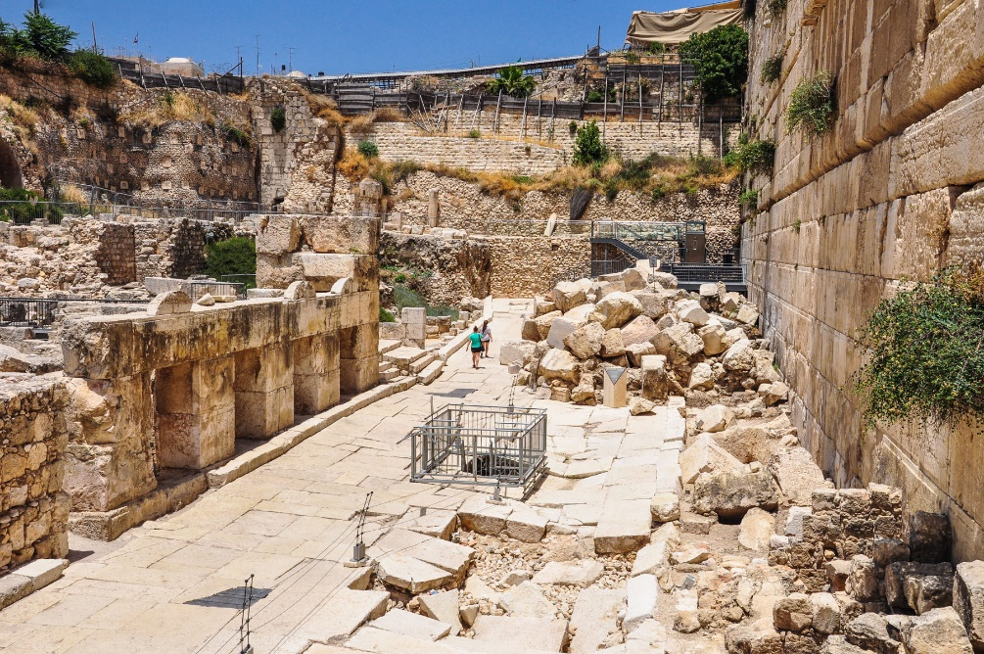
Image: Ruins of ancient Jerusalem

Luke 19:40
But Jesus answered, “I tell you, if these become silent, the stones will cry out!”

