Harmony Of Scriptures & Science Part 2
Prepared by Nathan L Morrison for Sunday April 29th, 2018
Text: Ps. 19:1; Is 40:8; Rom. 1:20
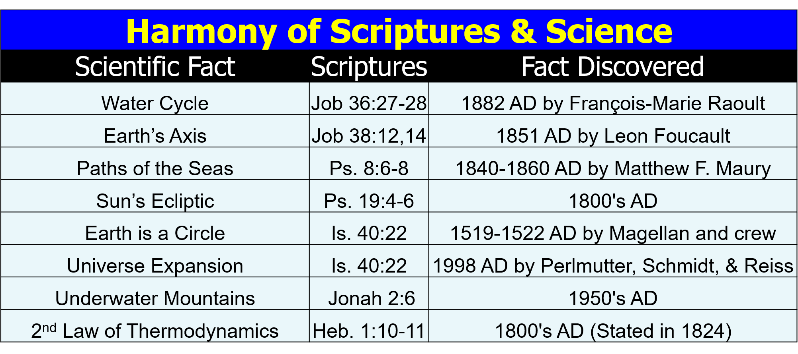
- The Water Cycle – Job 36:27-28
  - _________________________________
  - _________________________________
  - _________________________________
- Earth’s Axis – Job 38:12, 14
  - _________________________________
  - _________________________________
  - _________________________________
- Paths of the Seas – Ps. 8:6-8
  - _________________________________
  - _________________________________
  - _________________________________
- Sun’s Ecliptic – Ps. 19:4-6
  - _________________________________
  - _________________________________
  - _________________________________
- Earth is a Circle – Is. 40:22
  - _________________________________
  - _________________________________
  - _________________________________
- Universe Expansion – Is. 40:22
  - _________________________________
  - _________________________________
  - _________________________________
- Underwater Mountains – Jonah 2:6
  - _________________________________
  - _________________________________
  - _________________________________
- 2nd Law of Thermodynamics – Heb. 1:10-11
  - _________________________________
  - _________________________________
  - _________________________________

- Radio Waves – Job 38:35
  - _________________________________
  - _________________________________
  - _________________________________

Resources:
- Science Increasingly Makes the Case for God, Wall Street Journal Article by Eric Mataxas, 12/25/14: http://www.wsj.com/articles/eric-metaxas-science-increasingly-makes-the-case-for-god-1419544568
- http://www.evidencebible.com/witnessingtool/scientificfactsintheBible
- Water Cycle: http://en.wikipedia.org/wiki/Raoult%27s_law; http://en.wikipedia.org/wiki/Fran%C3%A7ois-Marie_Raoult ; http://ga.water.usgs.gov/edu/watercycle.html
- Earth’s Axis: http://en.wikipedia.org/wiki/Foucault_Pendulum; http://en.wikipedia.org/wiki/L%C3%A9on_Foucault
- Paths of the Seas: http://en.wikipedia.org/wiki/Matthew_Fontaine_Maury
- Sun’s Ecliptic Path: http://en.wikipedia.org/wiki/Ecliptic; http://en.wikipedia.org/wiki/Ecliptic_coordinate_system; http://earthsky.org/space/what-is-the-ecliptic
- Earth is a Circle: http://en.wikipedia.org/wiki/Ferdinand_Magellan; https://en.wikipedia.org/wiki/Juan_Sebasti%C3%A1n_Elcano
- Universe Expansion: http://www.bbc.com/news/science-environment-15165371; Nobel physics prize honors accelerating Universe find; BBC News; October 4, 2011; http://en.wikipedia.org/wiki/Accelerating_universe; Image at: http://www.universetoday.com/89449/accelerating-expansion-of-universe-discovery-wins-2011-noble-prize-in-physics/
- Underwater Mountains: http://en.wikipedia.org/wiki/Underwater_mountain_range; http://www.marianatrench.com/; http://en.wikipedia.org/wiki/Mariana_Trench
- 2nd Law of Thermodynamics: http://en.wikipedia.org/wiki/Second_law_of_thermodynamics; http://en.wikipedia.org/wiki/Nicolas_L%C3%A9onard_Sadi_Carnot
- Radio Waves: Modern Century Illustrated Encyclopedia, Vol. 12

For further study, or if questions, please Call: 804-277-1983 or Visit www.courthousechurchofcrist.com

Morrison Publishing, 2018

Harmony Of Scriptures & Science Part 2
Prepared by Nathan L Morrison for Sunday April 29th, 2018
Text: Ps. 19:1; Is 40:8; Rom. 1:20

Image: “Pillars of Creation” in the Eagle Nebula taken by the Hubble Telescope in 2014
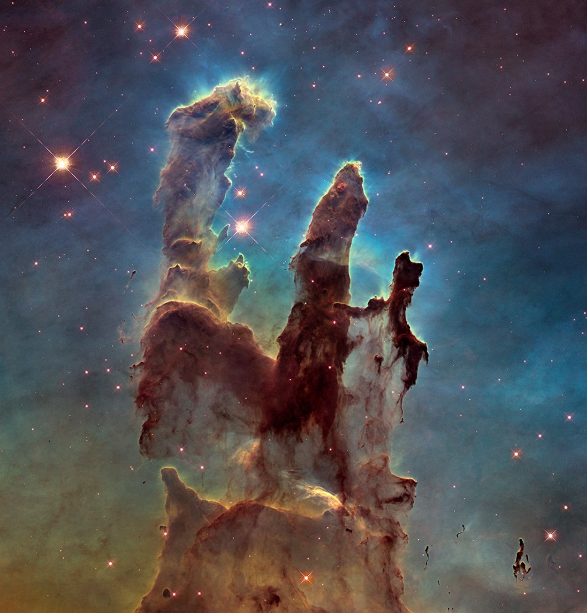

Psalms 19:1: To the Chief Musician. A Psalm of David.
“The heavens declare the glory of God; And the firmament shows His handiwork.”

Wall Street Journal article from 12/25/14, Science Increasingly Makes the Case for God by Eric Mataxas, declares that scientists are increasingly having to change their previous thoughts!

