Harmony Of Scriptures & Science Part 1
Prepared by Nathan L Morrison for Sunday April 22nd, 2018
Text: Ps. 19:1; Is 40:8; Rom. 1:20
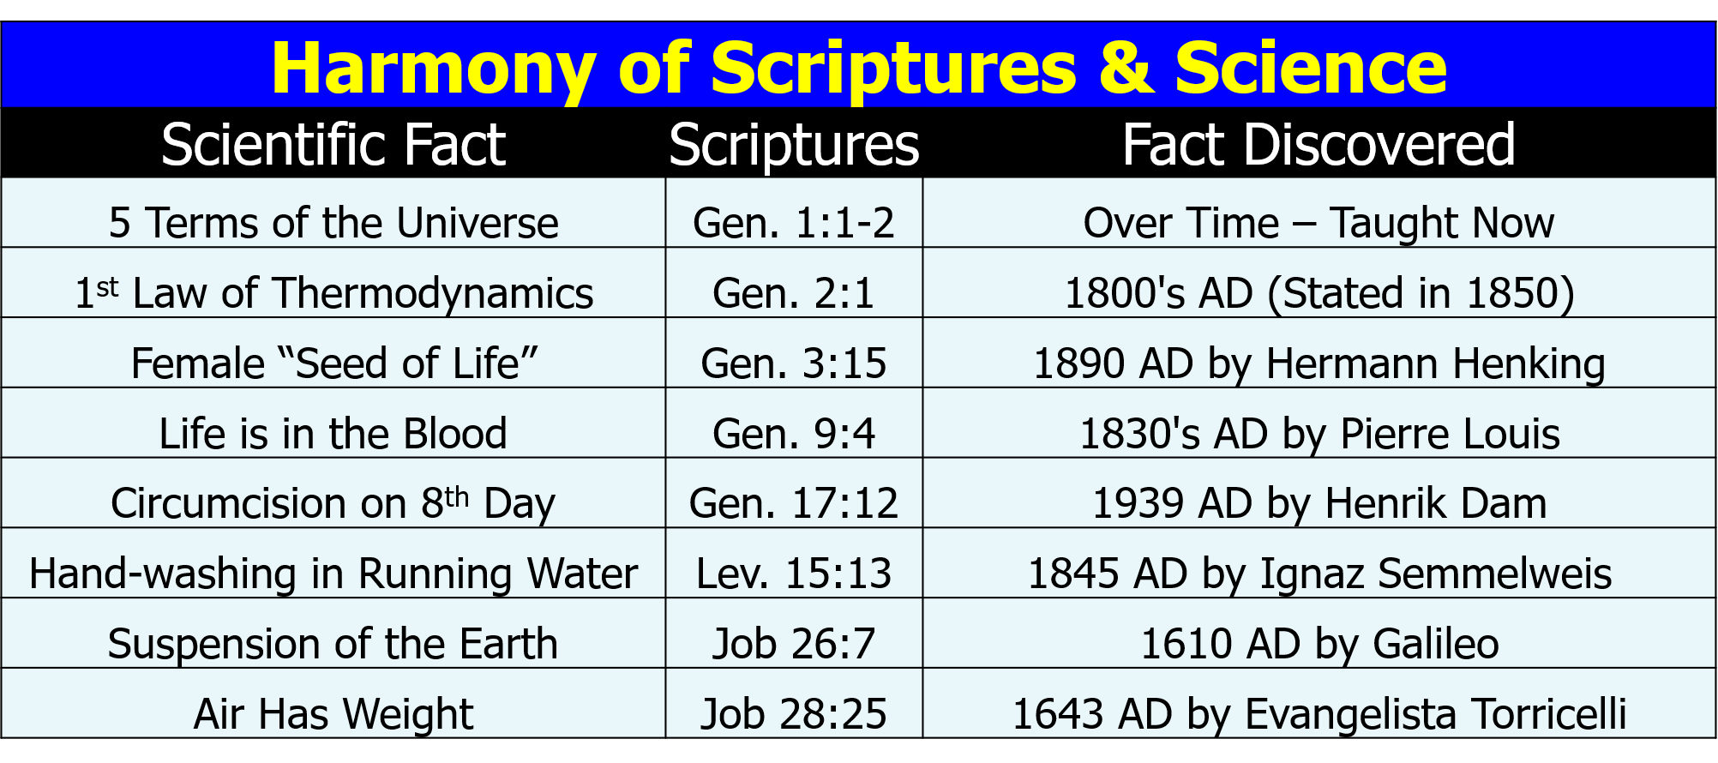
- 5 Terms of the Universe – Gen. 1:1-2
  - _____________________________________________
  - _____________________________________________
- 1st Law of Thermodynamics – Gen. 2:1
  - _____________________________________________
  - _____________________________________________
- Female “Seed of Life” – Gen. 3:15
  - _____________________________________________
  - _____________________________________________
- Life in the Blood – Gen. 9:4
  - _____________________________________________
  - _____________________________________________
- Circumcision on 8th Day – Gen. 17:12
  - _____________________________________________
  - _____________________________________________
- Hand-washing in Running Water – Lev. 15:13
  - _____________________________________________
  - _____________________________________________
- Suspension of the Earth in Space – Job 26:7
  - _____________________________________________
  - _____________________________________________
- Air has weight – Job 28:25
  - _____________________________________________
  - _____________________________________________

Harmony Of Scriptures & Science Part 2
Prepared by Nathan L Morrison for Sunday April 29th, 2018
Text: Ps. 19:1; Is 40:8; Rom. 1:20
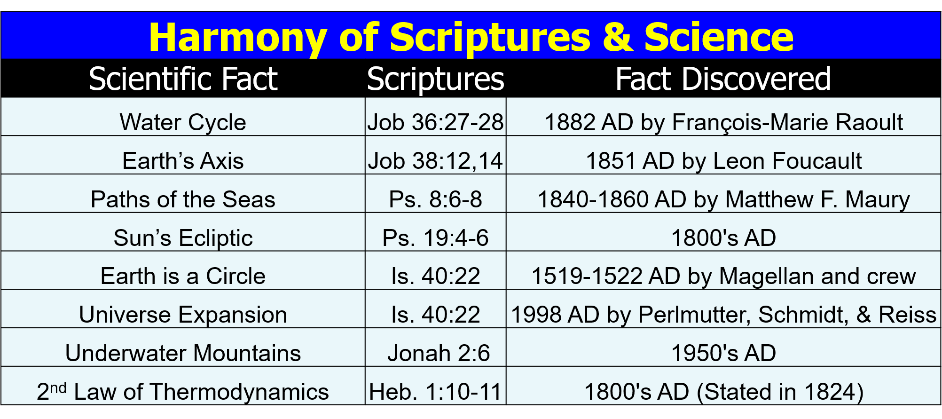
- The Water Cycle – Job 36:27-28
  - _____________________________________________
  - _____________________________________________
- Earth’s Axis – Job 38:12, 14
- _____________________________________________
- _____________________________________________
- Paths of the Seas – Ps. 8:6-8
- _____________________________________________
- _____________________________________________
- Sun’s Ecliptic Path – Ps. 19:4-6
- _____________________________________________
- _____________________________________________
- Earth is a Circle – Is. 40:22
- _____________________________________________
- _____________________________________________
- Universe Expansion – Is. 40:22
- _____________________________________________
- _____________________________________________
- Underwater Mountains – Jonah 2:6
- _____________________________________________
- _____________________________________________
- 2nd Law of Thermodynamics – Heb. 1:10-11
- _____________________________________________
- _____________________________________________

- Radio Waves – Job 38:35
  - _____________________________________________
  - _____________________________________________

Image: Painting, “Hands of Creation,” by Evelyn Patrick
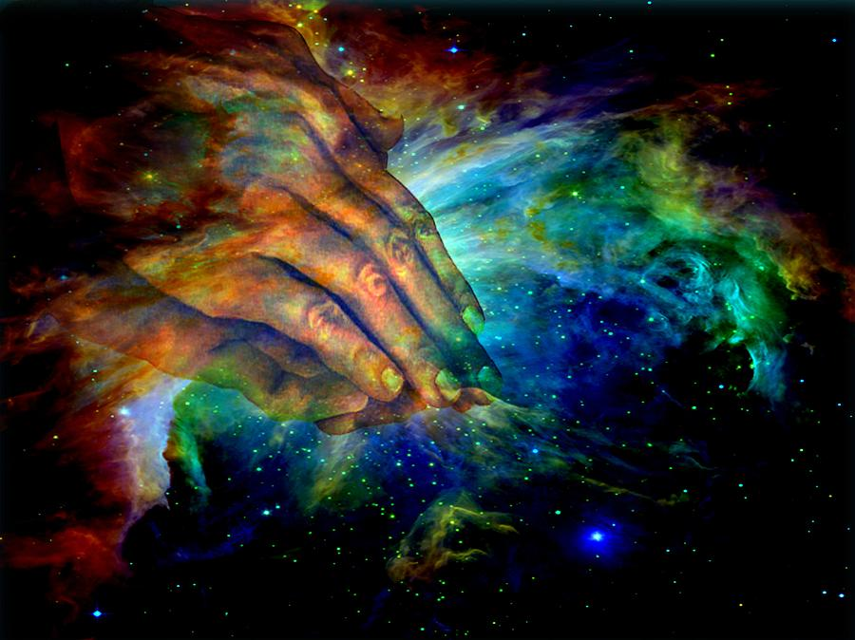

For further study, or if questions, please Call: 804-277-1983 or Visit www.courthousechurchofcrist.com

Morrison Publishing, 2018

Harmony Of Scriptures & Science Parts 1-2
Prepared by Nathan L Morrison for Sunday April 22nd & April 29th, 2018
Text: Ps. 19:1; Is 40:8; Rom. 1:20

Image: “Pillars of Creation” in the Eagle Nebula taken by the Hubble Telescope in 2014
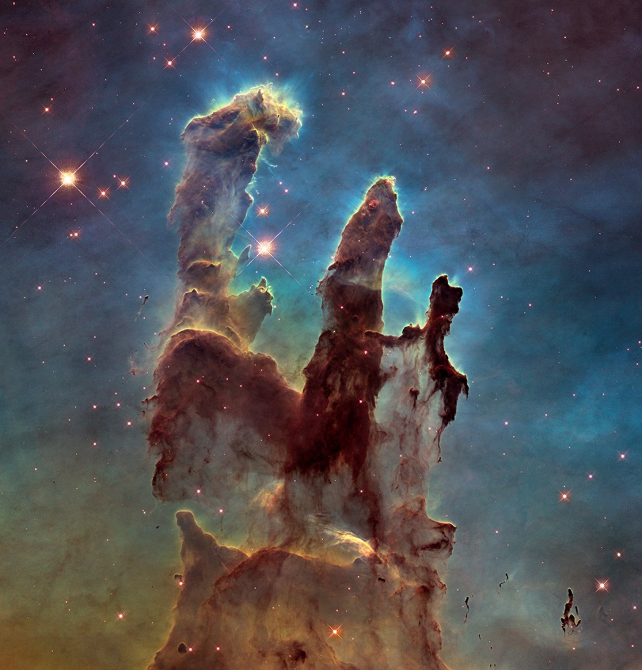

Psalms 19:1: To the Chief Musician. A Psalm of David.
“The heavens declare the glory of God; And the firmament shows His handiwork.”

Wall Street Journal article from 12/25/14, Science Increasingly Makes the Case for God by Eric Mataxas, declares that scientists are increasingly having to change their previous thoughts!

