Rupturing The Rapture
Prepared by Nathan L Morrison for Sunday December 17, 2023
Text: I Thessalonians 4:13-18 Scripture Reading: Mark 9:1

Intro
- There is confusion in the world about “end times” due to false doctrines that have been taught.
- “The Rapture” is part of the Premillennialist doctrine taught by many religious groups.
- Occasionally, such false doctrines gain mass media attention, such as “the Rapture.”
  - This false doctrine has been shown to be associated with Christianity in films, TV shows, comics, news, books, and just about every kind of media outlet. (The Left Behind series)
  - Bumper Stickers: “In case of the Rapture, this car will be without a driver!”
- The goal of our teaching is to help people escape the lies of Satan and come to the truth.
  - II Timothy 2:24-26: The Lord's bond-servant must not be quarrelsome, but be kind to all, able to teach, patient when wronged, with gentleness correcting those who are in opposition, if perhaps God may grant them repentance leading to the knowledge of the truth, and they may come to their senses and escape from the snare of the devil, having been held captive by him to do his will.
- This kind of news coverage and attention can cause Christians to be confused or question what they’re taught since these aren’t terms found in the Scriptures!
- Are we waiting for The Rapture?

Defining Premillennialism
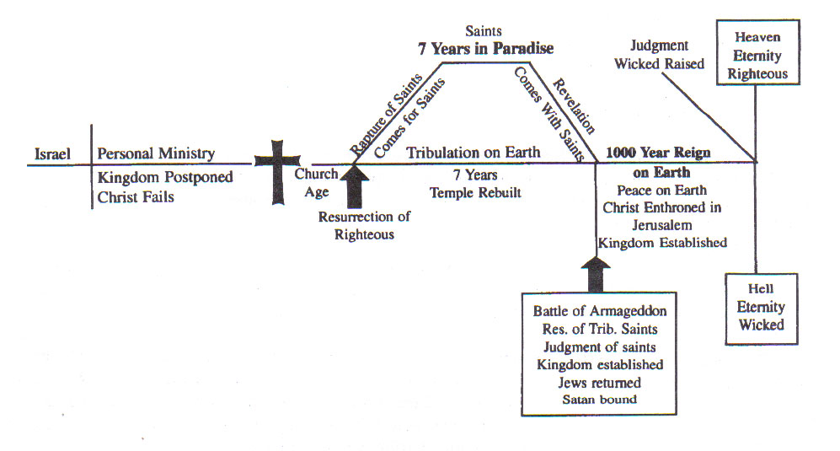
  - “Pre” = before; and “millennium” = 1,000
  - There are many varieties of Premillennialist teaching (Not all are alike)!
  - There is a basic shell but the particulars vary from group to group.
  - The basic doctrine of the Premillennial Theory:
    - Christ came to set up an earthly kingdom, but was rejected & crucified
    - God made a temporary plan: the church
    - Soon Christ secretly will raise the righteous dead & Rapture the living saints from earth
    - 7 years of Tribulation will follow
    - Christ will return with His saints to defeat Satan in a literal war: Battle of Armageddon
    - Christ will rule from Jerusalem on a literal throne in an earthly kingdom for 1,000 years
    - After the 1,000 years, Christ will raise the wicked for the final judgment
    - The righteous will go to Heaven, the wicked to Hell.

  - The Rapture (the event that begins it all)
    - “Rapture” is from Latin rapere in the Latin Vulgate for the Greek word harpazō [har-pad'-zo] (G726: “To snatch, or catch away”) in I Thessalonians 4:17, which is rendered by the phrase “caught up” in most English translations. (Rapture then is like Calvary, Latin) (From: theopedia.com/Rapture)
    - It is used of Philip in Acts 8:39, of Paul in II Corinthians 12:2, 4, and of the male Child in Revelation12:5: These use the phrases, “snatched,” and “caught up.”
    - The doctrine of the Rapture is an essential part of the Premillennial theory.
    - The Rapture speaks of a “secret, quiet” coming of the Lord in which He will remove His saints from the earth before the Tribulation.
  - What do the Scriptures say in regards to the Rapture (and Premillennialism)?

The Rapture Doctrine Contradicts Scripture
  - Claim Christ Came for an Earthly Kingdom
    - Christ failed and now must make a physical kingdom – John 18:37
    - John 18:36: Jesus denied this purpose.
    - Matthew 16:18-19: The church is the kingdom
    - Mark 9:1: Kingdom to come while disciples lived
    - Acts 2: King Jesus established His Kingdom, the church of Christ
  - Claim Christ Failed to Accomplish His Purpose
    - If failed 1st time, may fail again next time!
    - Psalm 2: God promised Jesus was King and that His plan cannot fail!
    - Acts 13:32-33: Paul affirmed God fulfilled this promise in Jesus! (Psalm 2:7)
  - Deny Christ Now Ruling on His Throne
    - Dethrones Christ – Matthew 28:18; I Timothy 6:15 (If not King now, what is He?)
    - Removes Christ’s Priesthood – Hebrews 4:14-16; 7:17 (Jesus is to be Priest on His throne; if His throne not yet established, neither is His priesthood!)
    - Convicts the apostles of falsehood – Acts 2:30-33; I Timothy 6:15 (Peter & Paul said He was King: “King of kings!”)
    - Acts 2:29-36: Peter affirmed He is ruling now on His throne (Heb. 12:2).
    - Colossians 1:13-14: If He is not on His throne, we cannot enter His kingdom: we are still in our sins!
  - Deny Christ Came to Die for Us
    - Makes the death of Christ not part of God's plan, but an accident.
    - Acts 2:22-23: “…this Man, delivered over by the predetermined plan and foreknowledge of God, you nailed to a cross by the hands of godless men and put Him to death.” Peter declared that it was all part of God’s plan!
  - Deny the church as God's Original Plan for His Kingdom
    - Denies “the last days” began on Day of Pentecost – Acts 2:16-21
    - Ephesians 1:3-7: God chose saints, those who would follow Jesus, “before the foundation of the world.”
    - Ephesians 3:8-12: The church is God's eternal purpose, not a temporary backup plan.
  - Claim Signs to Predict the Time of Christ's Coming
    - Jesus said no one knows “the day or the hour” but God the Father!
    - Matthew 24:35-36: Verses 1-35 discuss signs for the fall of Jerusalem; verses 36-51 affirm we cannot know the time of Christ's final coming.
  - The doctrine teaches two different resurrections from the dead:
    - It says there will be a resurrection of the righteous dead at the time of the Rapture, and a resurrection of the wicked dead at Judgment 1,007 years later.
    - The Scriptures say:
      - One resurrection of both righteous and wicked the same hour – John 5:28-29; Acts 24:15
      - Resurrection of believers on “the last day” – John 6:39-40; 11:24
      - Judgment Day on “the last day” – John 12:48
  - The doctrine teaches multiple comings of Christ:
    - They say there will be a “quiet, secret” coming of Christ when saints are snatched away in the Rapture. How secret or public varies group to group!
    - Another coming of Christ when He comes to establish His 1,000 year reign.
    - A final coming of Christ in judgment.
    - The Scriptures say:
      - One coming of Christ: His coming will begin the Day of Judgment!
      - John 5:28-29: The “shout” of I Thessalonians 4:16 is the voice the dead will hear.
      - II Thessalonians 1:6-10: When “He is revealed from heaven” and the righteous are “caught up” (I Thessalonians 4:17), the same day the wicked will also be punished!
      - II Corinthians 5:10: All men must appear before the judgment seat of Christ!
  - The doctrine teaches a “quiet, secret” coming of Christ:
    - They say there will be a “quiet, secret” coming of Christ when saints are snatched away in the Rapture. How secret or public varies group to group!
    - The Scriptures say:
      - Christ’s coming will not be a “secret, quiet” affair but a noisy, loud event!
      - I Thessalonians 4:16: Christ will “descend from heaven with a shout, with the voice of the archangel, and with the trumpet of God.”
      - II Peter 3:10: The world will be destroyed with a “roar” (NKJ: “a great noise”)!
      - Revelation 1:7: “Every eye will see Him!”
  - The doctrine teaches saints who made it to heaven will return to earth for 1,000 years:
    - They teach saints who were “Raptured” will return to earth with Christ for His 1,000 year reign.
    - Problems:
      - Revelation 20:4-5: The saints that reign for 1,000 years are beheaded martyrs! (Not all the saints, or even all the martyrs are raised!)
      - Revelation 20:6: No mention of earth or Jerusalem!
      - Can these be guilty of sin during the 1,000 years on earth?
      - If so, can they lose their reward? (If not, are they automatons?)
    - The Scriptures say:
      - Jesus won’t step foot on the earth again – I Thessalonians 4:16-17
      - Saints will meet Him in the clouds (air) and “always be with the Lord!” (No time limit placed on that!)
  - The Premillennial doctrine of the Rapture contradicts God’s word and gives false hopes!

Christ’s 2nd Coming
  - The central text used to support the Rapture (they use several) is I Thessalonians 4:13-18.
    - Premillennialists teach that both the righteous dead and living will be removed from this earth at a secret, quiet coming of Jesus.
    - They teach two comings of Jesus separated by seven years.
  - The central text used to refute the Rapture doctrine is I Thessalonians 4:13-18!
    - The text says Christ will return with a “shout, with the voice of the archangel, and the trumpet of God!” (I Thessalonians 4:16)
    - There is no distinction made of time, but speaks of one return!
  - I Thessalonians 4:13-5:4 speaks of Christ’s 2nd Coming (Acts 1:11) and shows:
    - I Thessalonians 5:2: The day of Christ will come like a “thief in the night” (Matthew 24:43-44; II Peter 3:10).
    - I Thessalonians 4:16: Christ’s 2nd Coming will be seen and heard by all, the righteous and the wicked alike – II Peter 3:10; Revelation 1:7 (Not quiet, can’t be missed!)
    - I Thessalonians 4:16-17; 5:3: On the day of Christ both the righteous and the wicked will be raised (John 5:28-29: The same “hour”: no time for additional literal 1,000 years!).
    - I Thessalonians 4:13-18; II Thessalonians 1:7-9: When Jesus comes to give His saints eternal rest, He will punish the wicked eternally (Matthew 25:34, 41, 46).
    - I Thessalonians 4:16-17: At the raising of the dead Judgment will begin for both the righteous and the wicked – Matthew 16:27; 25:31-46; II Timothy 4:1; Hebrews 9:27
    - I Thessalonians 4:17: “We shall always be with the Lord” cannot be reduced to 7 years, then for 1,000 years, then for eternity! It means for eternity!
  - God knows when Christ will return, & when He returns He will bring both Judgment & Reward with Him! (Hebrews 9:27; II Corinthians 5:10)

Conclusion
- Premillennialism and the Rapture part of it are a delusion and false teaching!
  - One cannot prove their theories nor find their terminology in God’s word!
  - Those who teach outside of Christ’s teachings do not have God – II John 9-11
- We have no need to be confused or misguided, when the Scriptures are very clear as to what will happen when Christ returns for the 2nd time!
  - We are to correct with gentleness and out of love (II Timothy 2:24-26).
- We do not wait for the Rapture, but wait for the return of Christ, to be “caught up” in the clouds and meet Him in the air to “always be with the Lord!” (I Thessalonians 4:16-17)
  - It is this event we are to comfort one another with (I Thessalonians 4:18)!
- Let us not be deceived with a dream of a secret “Rapture,” but focus our eyes on the “one hope” of His glorious return with “His mighty angels in flaming fire!” (II Thessalonians 1:7)
- If you are not a Christian, you need to be. Repent and be baptized!
- If a Christian in sin, don’t hesitate to make it right with God!
- Whatever your requests, let them be made known NOW while we stand & sing!

